Database Programming with SQL

12-1: INSERT Statements

Practice Activities

Objectives

* Give examples of why it is important to be able to alter the data in a database
* Construct and execute INSERT statements that insert a single row using a VALUES clause
* Construct and execute INSERT statements that use special values, null values, and date values
* Construct and execute INSERT statements that copy rows from one table to another using a

subquery

**Vocabulary**

Identify the vocabulary word for each definition below.

|  |  |
| --- | --- |
| User | Someone doing “real work” with the computer, using it as a  means rather than an end |
| Transaction | Consists of a collection of DML statements that form  a logical unit of work. |
| Explicit | Fully and clearly expressed; leaving nothing implied |
| INSERT INTO | Adds a new row to a table |

**Try It / Solve It**

Students should execute DESC tablename before doing INSERT to view the data types for each

column. VARCHAR2 data-type entries need single quotation marks in the VALUES statement.

1. Give two examples of why it is important to be able to alter the data in a database.

In principiu, tot ce ramane constant e schimbarea. Orice baza de date va trebui, la un moment dat, sa sufere modificari. Ex> studentii unei scoli auto (de soferi); Ex> o librarie din care dispar unele titluri si apar litere noi.

2. DJs on Demand just purchased four new CDs. Use an explicit INSERT statement to add each CD

to the copy_d_cds table. After completing the entries, execute a SELECT * statement to verify

your work.

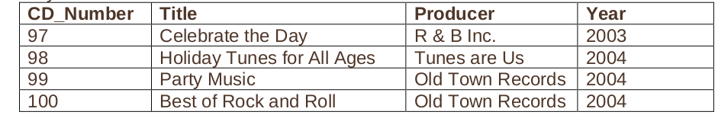

insert into copy_d_cds

(cd_number, title, producer, year)

values (97, 'Celebrate the Day', 'R & B Inc.', 2003)

insert into copy_d_cds

(cd_number, title, producer, year)

values (98, 'Holiday Tunes for All Ages', 'Tunes are Us', 2004)

insert into copy_d_cds

(cd_number, title, producer, year)

values (99, 'Party Music', 'Old Town Records', 2004)

insert into copy_d_cds

(cd_number, title, producer, year)

values (100, ‘Best of Rock and Roll', 'Old Town Records', 2004)

3. DJs on Demand has two new events coming up. One event is a fall football party and the other

event is a sixties theme party. The DJs on Demand clients requested the songs shown in the table

for their events. Add these songs to the copy_d_songs table using an implicit INSERT statement.

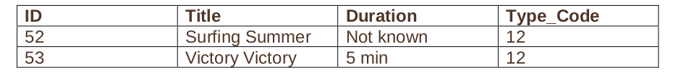CREATE TABLE copy_d_songs

AS ( SELECT * FROM d_songs);

DESCRIBE copy_d_songs;

DESCRIBE d_songs;

INSERT INTO copy_d_songs

VALUES(52,'Surfing Summer',NULL,NULL,12);

INSERT INTO copy_d_songs

VALUES(53,'Victory Victory','5 min',NULL,12);

SELECT * FROM copy_d_songs ; pt verificare

4. Add the two new clients to the copy_d_clients table. Use either an implicit or an explicit INSERT.

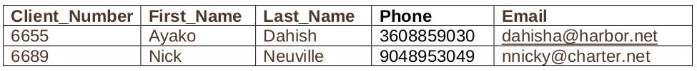 CREATE TABLE copy_d_clients

AS ( SELECT * FROM d_clients);

INSERT INTO copy_d_clients(client_number,first_name,last_name,phone,email)

VALUES(6655,'Ayako','Dahish',3608859030,['dahisha@harbor.net](mailto:'dahisha@harbor.net)');

INSERT INTO copy_d_clients(client_number,first_name,last_name,phone,email)

VALUES(6689,'Nick','Neuville',3608859030,'nnicky@charter.net');

5. Add the new client’s events to the copy_d_events table. The cost of each event has not been

determined at this date.

CREATE TABLE copy_d_events

AS ( SELECT * FROM d_events);

INSERT INTO copy_d_events(id,name,event_date,description,cost,venue_id,package_code,theme_code,client_number)

VALUES(110,'Ayako Anniversary',TO_DATE('07-Jul-2004','dd-Mon-yyyy'),'Party for 50, sixties dress, decorations',0,245,79,240,6655); - am facut costul 0, ca nu poate fi null (logic in practica vorbind)

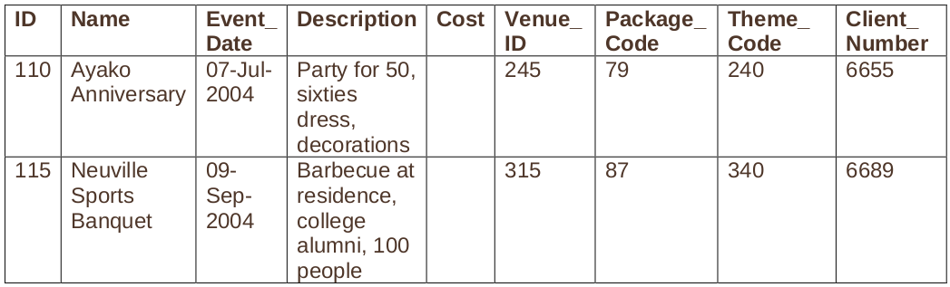

6. Create a table called rep_email using the following statement:

CREATE TABLE rep_email (

id NUMBER(3) CONSTRAINT rel_id_pk PRIMARY KEY,

first_name VARCHAR2(10),

last_name VARCHAR2(10),

email_address VARCHAR2(10))

Populate this table by running a query on the employees table that includes only those employees

who are REP’s.

Faza e ca employee id are precizie 3 si scala 0 in statementul de mai sus. Dar in tabela employees el are 6 cu 0. Si atunci modificam:

ALTER TABLE rep_email DROP column id;

ALTER TABLE rep_email ADD id NUMBER(6,0) CONSTRAINT rel_id_pk PRIMARY KEY;

INSERT INTO rep_email(id, first_name, last_name, email_address)

SELECT employee_id, first_name, last_name, email

FROM employees

WHERE job_id LIKE '%\_REP' ESCAPE '\';